NAME: PRATHIBA K
REG NO: 192421163
COURSE: COMPUTER ARCHITECTURE CODE: CSA1204

Q1. Design and Simulation of Register Transfer, Arithmetic and Logic Operations

Aim:
To design and simulate a system that performs register transfer operations along with basic arithmetic and logic operations such as addition, subtraction, AND, and OR, and to analyze the role of the ALU during processing.

Introduction

A register is a small, high-speed storage location inside the processor used to temporarily store data and instructions. Register Transfer refers to moving data from one register to another.
The Arithmetic Logic Unit (ALU) is the main processing unit responsible for performing arithmetic and logical operations. In this experiment, multiple registers are connected to an ALU to demonstrate how data is transferred and processed.
R1 = 10

R2 = 5

# Register Transfer R3 = R1
print("Register Transfer: R1 -> R3") print("R3 =", R3)

# Arithmetic Operations

print("\nArithmetic Operations") print("Addition:", R1 + R2) print("Subtraction:", R1 - R2)

# Logical Operations R1_binary = 0b1010 R2_binary = 0b1100

print("\nLogical Operations")

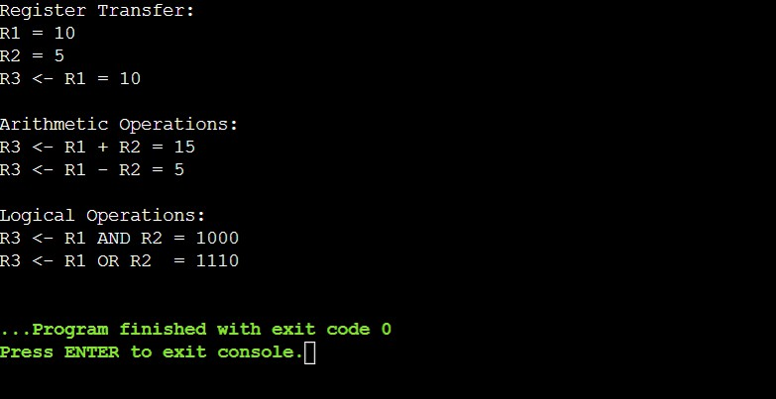
print("AND:", bin(R1_binary & R2_binary)) print("OR :", bin(R1_binary | R2_binary))

Result and Analysis

The designed system successfully demonstrates register-to-register data transfer and ALU-based processing. Addition and subtraction are performed as arithmetic operations, while AND and OR are performed as logical operations.

The experiment shows that proper control signals are required to select registers, transfer data and determine the ALU operation. Multiple registers allow intermediate values to be stored and transferred efficiently.

Q2. Single-Bus and Multi-Bus Organization Aim
To create a model of a computer system using single-bus and multi-bus organization, perform data transfer between registers, memory and I/O, and compare their time and efficiency.

Introduction

A bus is a communication pathway used to transfer data between different components of a computer system. Registers, memory and I/O devices communicate with each other through buses.
Two common bus organizations are:

- Single-bus organization

- Multi-bus organization

# Single-Bus and Multi-Bus Organization

R1 = 20

R2 = 10

print("SINGLE-BUS ORGANIZATION")

print(" ")

print("R1 =", R1)

print("R2 =", R2)

print("Step 1: R1 -> Common Bus") print("Step 2: R2 -> Common Bus")

result_single = R1 + R2

print("ALU Operation: R1 + R2") print("Result =", result_single)

print("\nMULTI-BUS ORGANIZATION")

print(" ")

print("R1 -> Bus A") print("R2 -> Bus B")

result_multi = R1 + R2

print("ALU Operation: R1 + R2") print("Result =", result_multi)

print("\nCOMPARISON")

print("Single-Bus : Sequential data transfer") print("Multi-Bus : Parallel data transfer")

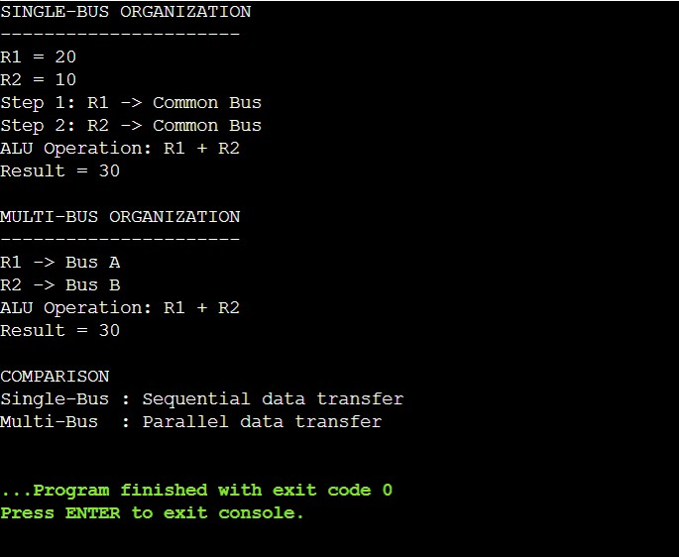

Result

The single-bus and multi-bus systems were modeled successfully. The multi-bus organization provides faster and more efficient data transfer because it supports greater parallelism.

Q3. Five-Stage Instruction Pipeline Aim
To simulate a 5-stage instruction pipeline consisting of Fetch, Decode, Execute, Memory and Write-back, and compare its performance with a non-pipelined processor using speedup and throughput.

Introduction

Pipelining is a technique used in processors to improve instruction execution speed. An instruction is divided into several stages, and different instructions can occupy different stages simultaneously.

# Five-Stage Instruction Pipeline

instructions = ["I1", "I2", "I3", "I4", "I5"]

stages = ["IF", "ID", "EX", "MEM", "WB"]

print("5-STAGE INSTRUCTION PIPELINE\n")

# Pipeline execution

for cycle in range(1, len(instructions) + len(stages)): print("Cycle", cycle, ":", end=" ")

for i in range(len(instructions)): stage = cycle - i - 1

if 0 <= stage < len(stages):

print(instructions[i] + "-" + stages[stage], end=" ")

print()

# Performance calculation

non_pipelined = len(instructions) * len(stages) pipelined = len(instructions) + len(stages) - 1 speedup = non_pipelined / pipelined

print("\nPerformance Analysis")

print("Non-pipelined cycles =", non_pipelined) print("Pipelined cycles =", pipelined) print("Speedup =", round(speedup, 2))Result
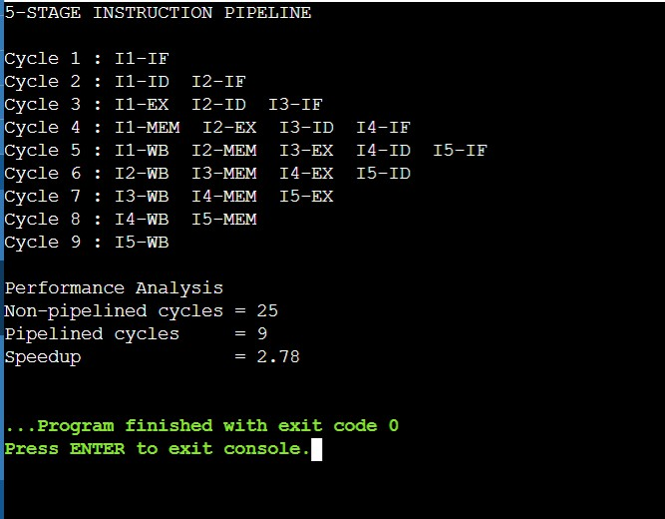

The five-stage pipeline was successfully simulated. The pipelined processor required fewer cycles than the equivalent non-pipelined processor.

Q4. Pipeline Hazards and Hazard Resolution Techniques Aim
To develop a pipeline execution scenario containing data, control and structural hazards, observe their effects and implement stalling, data forwarding and branch prediction techniques.

Introduction

A pipeline hazard is a situation that prevents the next instruction from executing in its normal pipeline cycle.
There are three major types:

- Data Hazard

- Control Hazard

- Structural Hazard

# Pipeline Hazards and Hazard Resolution

print("PIPELINE HAZARDS\n")

# Data Hazard

print("1. DATA HAZARD") print("I1: R1 <- R2 + R3") print("I2: R4 <- R1 + R5")
print("Cause: I2 depends on the result of I1") print("Solution: Data Forwarding")

# Control Hazard

print("\n2. CONTROL HAZARD")

print("Instruction: BEQ R1, R2, TARGET")

print("Cause: Next instruction depends on branch decision") print("Solution: Branch Prediction")

# Structural Hazard

print("\n3. STRUCTURAL HAZARD")

print("Instruction Fetch and Data Access use the same resource") print("Cause: Hardware resource conflict")
print("Solution: Stalling")

# Summary

print("\nHAZARD RESOLUTION SUMMARY")

print("Data Hazard -> Forwarding") print("Control Hazard -> Branch Prediction") print("Structural Hazard -> Stalling")
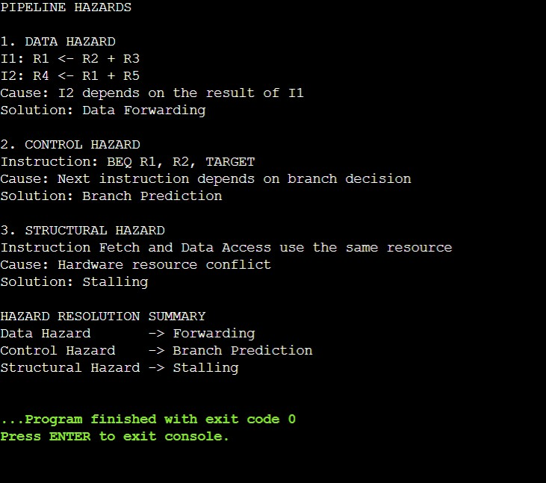

Result

The three major pipeline hazards were identified and their effects on instruction execution were analyzed. Stalling, forwarding and branch prediction were applied as appropriate hazard-resolution techniques.

Q5. Superscalar, Out-of-Order, Speculative Execution and SMT Aim
To analyze a processor supporting superscalar, out-of-order and speculative execution, and study hyper-threading and simultaneous multithreading (SMT) to evaluate instruction throughput and resource utilization.

Introduction

A superscalar processor can execute more than one instruction in a single clock cycle by using multiple execution units.
For example:

┌──► ALU 1 Instructions ─┼──► ALU 2
├──► FPU

└──► Load/Store Unit

This allows independent instructions to execute in parallel.

# Superscalar, Out-of-Order, Speculative Execution and SMT

instructions = [

("I1", "ADD", "Waiting"),

("I2", "SUB", "Ready"),

("I3", "AND", "Ready"),

("I4", "OR", "Ready")

]

print("SUPERSCALAR EXECUTION")

print(" ")

for instruction, operation, status in instructions: if status == "Ready":
print(instruction, "->", operation, "executed")

print("\nOUT-OF-ORDER EXECUTION")

print(" ")

print("I1 is waiting for data") print("I2 is ready -> Execute I2") print("I3 is ready -> Execute I3")
print("I1 executes after data becomes available")

print("\nSPECULATIVE EXECUTION")

print(" ")

branch_prediction = "TAKEN"

print("Branch Prediction:", branch_prediction) print("Instructions on predicted path are executed speculatively")

print("\nSMT / HYPER-THREADING")

print(" ")

print("Thread 1 -> Uses processor resources") print("Thread 2 -> Uses processor resources") print("Both threads share processor resources")

print("\nPERFORMANCE")

print("Multiple instructions and threads can progress in parallel.")

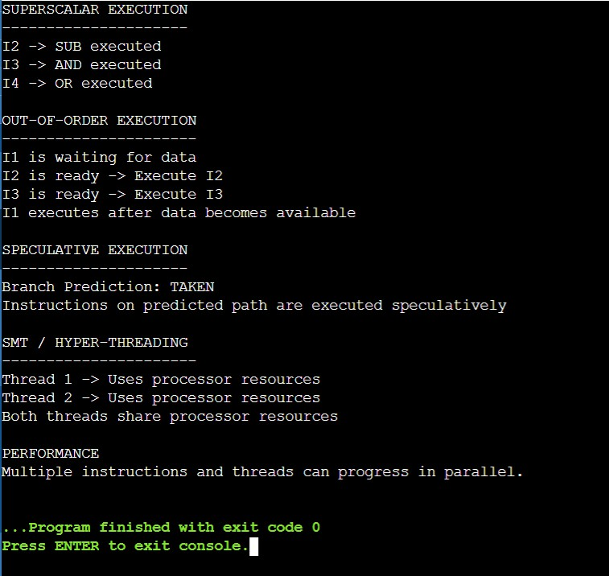

Result

The operation of superscalar, out-of-order and speculative execution was analyzed along with hyper-threading and SMT. These techniques allow multiple instructions or threads to make progress in parallel and can improve instruction throughput and processor resource utilization.

